. Phoenix Stroke Club
Newsletter September 2016

Summer Outings.

This years outings were on Monday 1st, Tuesday 9th and Wednesday10th of August toTilgate Park.
The weather was glorious on all three days.
There is a covered area where we had a familiarization session with some of the animals followed by a delicious Lunch delivered in from the Cafe.
We then wandered around the animals at our leisure including feeding the Meerkats on Tuesday and Wednesday.
Thanks go to Santander and the Co-Op F/C for helping with the funding and the Co-Op for helping on all three days.

The Thursday group went to Nymans on the11th August where they had a wonderful outing. The sun shone, the surroundings were beautiful and lunch was enjoyed. Several members enjoyed a buggy ride around the grounds and some visited the House which was often frequented by various ‘celebrities’ over the years including the gorgeous Vivian Leigh. Once again thanks go to Santander for helping with the funding.

The Carers Coffee Mornings will be on the 19th, 20th and 21st October in the Youth Wing next door to the club room at 10:30 each day to coincide with the time members are dropped off

P

Tuesday group examining a snakeskin.

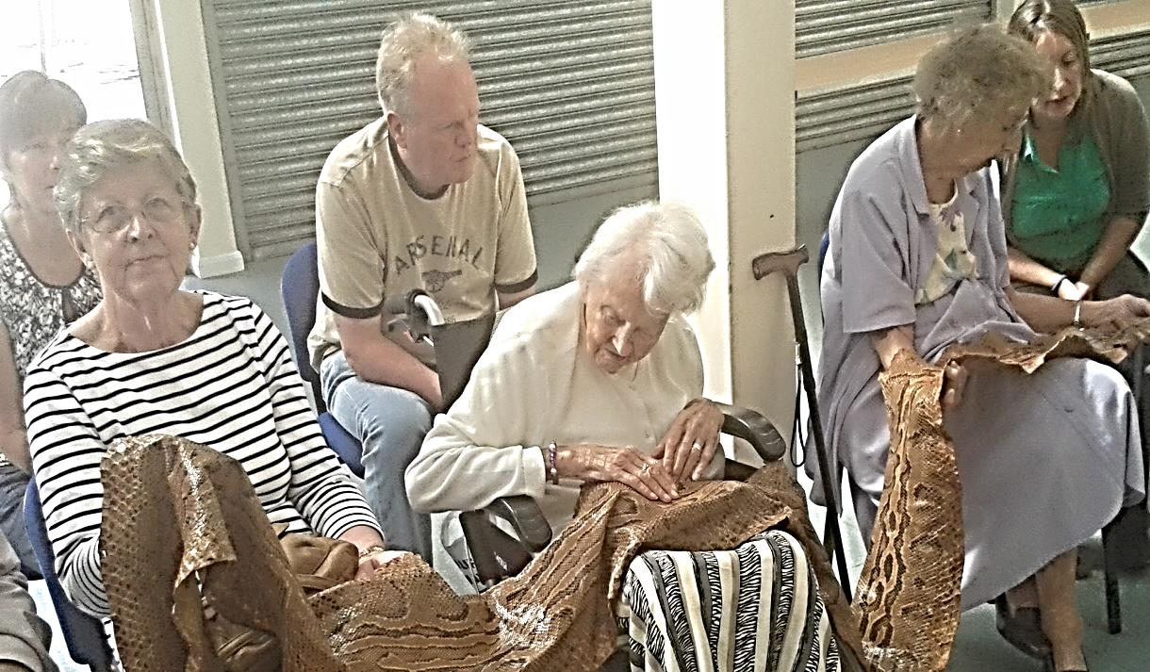

Here’s a photo of Terry and Gary from the Thursday group enjoying the day:
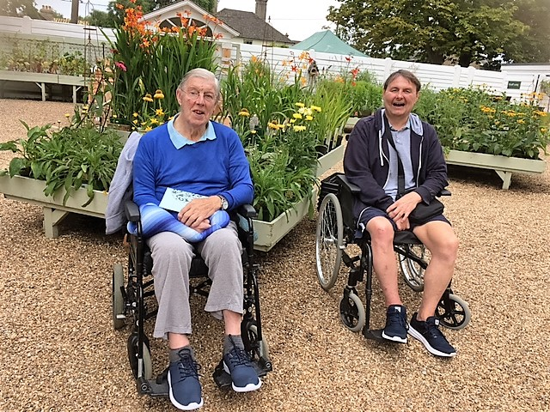

Activities at the club.

We have had our own version of Pointless facilitated by David Moore.

We have had a talk on Diabetes by a member of the Diabetes society.

We have had a visit from Geoffrey James (entertainer) and his keyboard playing assistant Jean.

The Fire brigade has been and talked to us about Fire safety in the home and reminded us that they will fit smoke detectors.

We have had demonstrations of lacemaking and quilting.

David, Christine and the Red Cross continue to visit for our regular exercise classes and hand and shoulder massages.

Shelley (OT) and Beth (Physio) have also continued to visit to advise members on exercises, therapies etc. This is a free service to those who are interested in the scheme. It may include one to one confidential time with members and/or Carers for an assessment, or taking part in a small group session. Shelleys next visit is on the 28th September and 19th October.

Donations and Funding News.

Donations we have gratefully received in addition to the regular ones from our members and sadly from bequests are as mentioned previously Santander and the Co-op F/C.
Lifeline, which is a volunteer organization that provides transport to Rudgwick residents and Betty Farleys family have donated some of Bettys beautiful crafts for us to sell to raise funds.

The Dragon Clay Club has donated the exceptional amount of £1600 from this year’s shoot. Our thanks go to them, especially to Sue Shore, one of our Thursday members who owns the ground where the shoot takes place. Here’s a photo of Don Burstow, one of our Trustees accepting the generous cheque at the recent event.

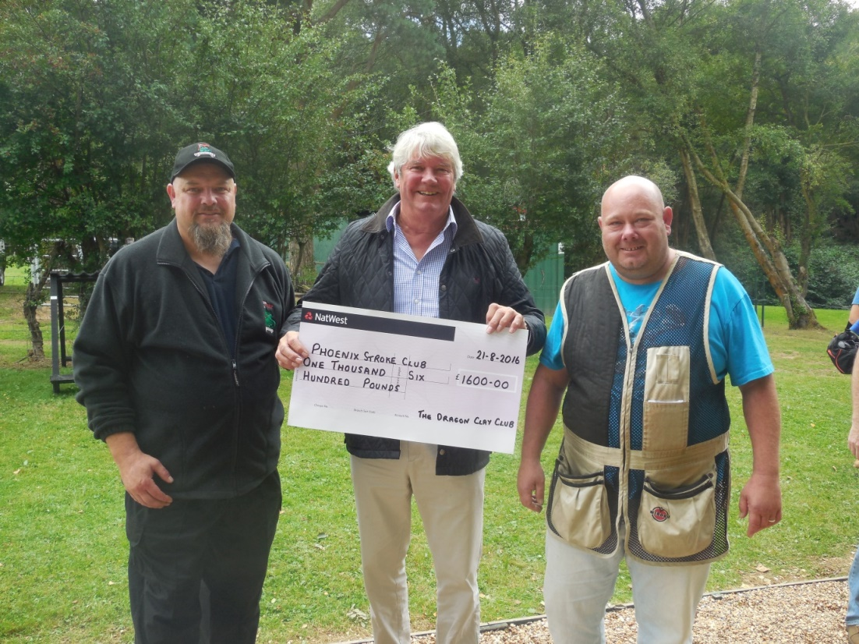

Previous role of a Tuesday member.

Below are things he would have done in his role as a Crime Prevention Officer when he was in the police force. (a job now done by a civilian.)
- Talks regarding safety and security to groups like us, offices, shops and businesses. He was once told off for being rude, by a member of the WI when he said his wife’s credit card had been stolen and the thief had spent less than her (his wife had heard it before).
- Visiting homes, suggesting safety measures (including Tony Armstrong Jones).
- Fitting temporary and personal alarms prior to permanent installation by an alarm company.
- Advising local councils on things such as lighting.
- Radio interviews regarding house security especially at holiday and Christmas times.
- TV at Sotherbys.
- Bicycle, household goods (TVs)and personal item (jewelry) marking,
- Checking location and safety of guns.
- Warning about letting unknown people into houses.

New Arrivals and Departures.

Kathryn has joined the Thursday Group.
Betty Farley from our Monday group has sadly passed away following a long stay in Hospital, our thoughts are with her family.
Emma our Wednesday volunteer and Amber our Thursday volunteer are both leaving us to go to Uni.
Peter has joined us as a volunteer on a Monday and Janine is joining us on a Tuesday.
John Pickersgill is taking a break but we are looking forward to having him back as soon as possible.

Recycling.

We have the facility to re-cycle printer cartridges and old mobile phones to raise funds.

Gardening Gloves.

If anyone can use new right hand gardening gloves please see Ann.

Panto.
This years Panto will be Cinderella on Wednesday 21st December. Please keep your eyes peeled for suitable costumes. Don’t forget to let Ann or Judy know which role you would like to be considered for (members, carers or volunteers.)

PHOENIX CLUB HOLIDAY

BOURNEMOUTH - 12 TO 16 SEPTEMBER 2016

A group of members & carers enjoyed our holiday to Bournemouth from 12 to 16 September. It was our fourth visit to the Elstead Hotel and once again, it was excellent with very friendly, helpful staff, good food and service.

All the outings went well. We visited Mapperton House & Gardens near Beaminster which is the home of the Earl & Countess of Sandwich – very enjoyable despite occasional heavy showers and delays with road works on the return trip. The weather was glorious for the visit to Bournemouth sea front and the accessible land train was well used. Thanks to the hotel who organized an early evening meal, we managed a trip to the Pavilion Theatre to see “That’ll be the Day” – we were able to stop right outside the theatre to unload and load and we had three wheel chair spaces in the auditorium. The final trip to Swanage was a great success and everyone enjoyed the brief trip on the Steam Railway. The return journey was made via the chain ferry from Studland to Sandbanks.

The Trustees are very grateful this year for financial support from West Sussex County Council. My thanks go to helpers John, Ian, Natalie & Izzie, members of Boscombe & Southdown Rotary & Inner Wheel Clubs who helped on our outings, all the wonderful staff at the Elstead Hotel, Paul – our coach driver and the Holbrook Club for allowing us to use their car park for pick up & drop off.

LESLEY NIVEN

The Phoenix Stroke Club, c/o Forest School, Comptons Lane, Horsham, RH13 5NW.
Tel: 01403 268130. Charity No: 278998
www.phoenixstrokeclub.org .uk

